**DAILY ONLINE ACTIVITIES SUMMARY**

|  |  |  |  |  |  |  |  |
| --- | --- | --- | --- | --- | --- | --- | --- |
| **Date:** | | **23/05/2020** | | | | | |
| **Name of the Faculty** | | **Shruthi Shetty J** | | | | | |
| **No. of Students Allotted for monitoring** | | | | | **26** | | |
| **Progress** | | | | | **Good** | | |
| **Whether collected report from all the allotted students** | | | | | **24 submitted** | | |
| **Online Test Summary** | | | | | | | |
| **Subject** | **Operation Research test** | | | | | | |
| **Semester** | **6** | | | **Duration** | | **1 HOUR** | |
| **No. of students Taken** | | | **107** | **Passing %** | | **95.3** | |
| **Certification Course Summary** | | | | | | | |
| **Course** | | **FDP on IOT and Cyber Security organized by Cambridge Institute of Technology and FDP on AI by AIET.** | | | | | |
| **Certificate Provider** | | **CIT,AIET** | | | **Duration** | | **3 Hours** |
| **Coding Challenges** | | | | | | | |
| **Problem Statement:** Check whether the given strings are ANAGRAM( Student can also select their own problem statement)  Example 1:  Input1: [1, 2, 3, 4, 5, 6, 7] and k = 3  Output1: [5, 6, 7, 1, 2, 3, 4]  Explanation:  rotate 1 steps to the right: [7, 1, 2, 3, 4, 5, 6]  rotate 2 steps to the right: [6, 7, 1, 2, 3, 4, 5]  rotate 3 steps to the right: [5, 6, 7, 1, 2, 3, 4]  Example 2:  Input2: [-1, -100, 3, 99] and k = 2  Output2: [3, 99, -1, -100]  Explanation:  rotate 1 steps to the right: [99, -1, -100 3]  rotate 2 steps to the right: [3, 99, -1, -100] (students can also select problem statement of their choice) | | | | | | | |
| **Status: 25** | | | | | | | |
| **Uploaded the report in Github** | | | | | **Yes** | | |
| **If yes Repository name** | | | | | <https://github.com/ShruthiShettyJ/daily-report> | | |
| **Uploaded the report in slack** | | | | | **Yes** | | |

Online Test Details: (Attach the snapshot and briefly write the report for the same)

Certification Course Details: (Attach the snapshot and briefly write the report for the same)

Coding Challenges Details: (Attach the snapshot and briefly write the report for the same)

**Certification Course Summary:**

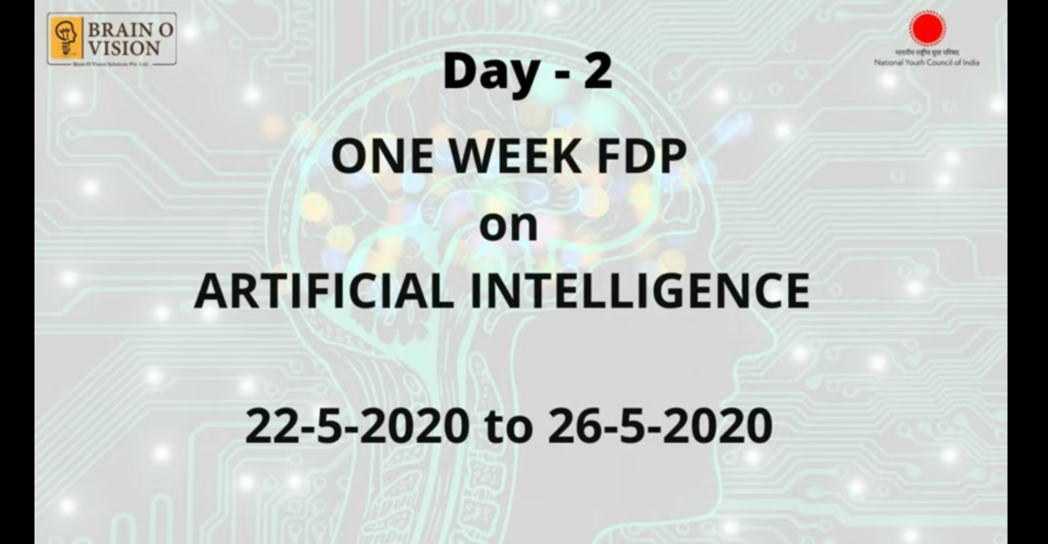

**Sample Students Report:**

